

**ABSTRACT**

**ABSTRACT**

Biscuits are consumed throughout the world for their nutritional value and also can be stored for longer durations. Biscuit manufacturing is a major processed food sector. Biscuits are available in a wide range of shapes, fillings, colors, and toppings and are hence accepted by consumers of all age groups. Major and minor ingredients used during manufacturing of biscuits play an important role, and the chemistry behind them must be well understood by biscuit manufacturers to maintain quality and to avoid batch variations. The method of manufacturing used nowadays is either a fully automated or a semiautomated plant in the organized sector, but it is fully dependent on humans in the unorganized sector. Apart from the method of manufacturing, packaging also plays a multiple role, that is, safeguards the product from contamination and attracts the consumer. This article outlines and describes the chemistry and methods associated with the manufacturing of biscuits.

**INDEX**

|  |  |  |
| --- | --- | --- |
| **SR. NO.** | **TOPIC** | **PAGE NO.** |
| 1 | Introduction | 5-7 |
| 2 | Purpose of Project | 8-9 |
| 3 | Hardware & Software requirement | 10-12 |
| 4 | Software Requirement Specification | 13-23 |
| 5 | Feasibility STUDY | 24-27 |
| 6 | Selected Software Tools | 28-35 |
| 7 | E-R Diagram | 36-37 |
| 8 | Data Flow Diagram | 38-41 |
| 9 | Data Dictionary | 42-43 |
| 10 | Applied Tables | 43-48 |
| 11 | Screen Layouts | 49-61 |
| 12 | Coding | 62-145 |
| 13 | System Testing | 146-148 |
| 14 | Conclusion | 149-150 |
| 15 | Bibliography | 151-152 |

**Introduction**

1. **INTRODUCTION**

BCA Cookies is a website for BCA Cookies for selling & purchasing online products. BCA Cookies is a biscuits manufacturing company, was incorporated in January 2018 and commenced its commercial operations of manufacturing and selling of biscuits under brand SAAII Biscuits ever a period we have established strong manufacturing capabilities and have invested substantially in developing consumer preference for our products. Our trademark is latest brand in biscuit manufacturing industry. We are committed to invest in brand, manufacturing capabilities, deliverables and distribution strength.

We have three branches of BCA Cookies in Kanpur. After establishing our foothold in biscuit industry, we continued to adopt strategy to indentify and commercialize profitable growth opportunities by leveraging established brand and distribution network. Following this strategy, we are planning into manufacturing of “Cake and candies” through our wholly owned subsidiary “BCA Cookies”.

* 1. **Objective**

The objective of the project is to know the consumers preferences for BCA Cookies, to study the Market Potential of BCA Cookies and the report contains a brief introduction of BCA Cookies. The company BCA Cookies has interests in various sectors and they provide consistent quality products to meet the customer requirements.

Satisfying our customers is an essential element to staying in business in this modern world of global competition. We must satisfy and even delight our customers with the value of our products and services to gain their loyalty and repeat business.

**Purpose Of Project**

1. **Purpose of project**

BCA Cookies is working to provide its product to Distributor and Customer direct at company rate via online.

The Main Purpose of BCA Cookies is that, All Customer and Distributor can purchase or product online directly on company manufacturing price without any agency and third mediator.

* 1. **Current Problems**
* Customer can’t purchase any biscuits products online.
* Customer purchase products with shopkeepers and shopkeepers purchase products with agency.
* Shopkeepers and agency sell the product to customers with their beneficiary price.
* Sometimes customers and shopkeepers have to face lake of stock.

Hardware & Software Requirement

1. **Hardware & Software Requirement**

**3.1 Hardware Requirement**

**Sever Configuration**

* Processor 1.6 GHz
* 512 MB RAM
* 20 GB Free Space in Hard Disk

**Client Configuration**

* Processor 1 GHz
* 128 MB RAM
* 10 GB Free Space in Hard Disk

**3.2 Software Requirement**

**Server Configuration**

* Windows server or other equivalent OS
* XAMPP SERVER (APACHE)
* MYSQL
* Internet Explorer 5.0 or Compatible Browser.

**Client Configuration**

* Windows XP or other equivalent OS
* Internet Explorer 5.0 or compatible web browser

**Software Requirement**

**Specification**

1. **Software Requirement**

The software, Site Explorer is designed for management of web sites from a remote location.

**INTRODUCTION**

**Purpose:** The main purpose for preparing this document is to give a general insight into the analysis and requirements of the existing system or situation and for determining the operating characteristics of the system.

**Scope:** This Document plays a vital role in the development life cycle (SDLC) and it describes the complete requirement of the system. It is meant for use by the developers and will be the basic during testing phase. Any changes made to the requirements in the future will have to go through formal change approval process.

**DEVELOPERS RESPONSIBILITIES OVERVIEW:**

The developer is responsible for:

* Developing the system, which meets the SRS and solving all the requirements of the system?
* Demonstrating the system and installing the system at client's location after the acceptance testing is successful.
* Submitting the required user manual describing the system interfaces to work on it and also the documents of the system.
* Conducting any user training that might be needed for using the system.
* Maintaining the system for a period of one year after installation.

## FUNCTIONAL REQUIREMENTS:

**OUTPUT DESIGN**

Outputs from computer systems are required primarily to communicate the results of processing to users. They are also used to provides a permanent copy of the results for later consultation. The various types of outputs in general are:

* External Outputs, whose destination is outside the organization.
* Internal Outputs whose destination is with in organization and they are the
* User’s main interface with the computer.
* Operational outputs whose use is purely with in the computer department.
* Interface outputs, which involve the user in communicating directly with

**OUTPUT DEFINITION**

# The outputs should be defined in terms of the following points:

* + - Type of the output
    - Content of the output
    - Format of the output
    - Location of the output
    - Frequency of the output
    - Volume of the output
    - Sequence of the output

It is not always desirable to print or display data as it is held on a computer. It should be decided as which form of the output is the most suitable.

For Example

* + - Will decimal points need to be inserted
    - Should leading zeros be suppressed.

**Output Media:**

In the next stage it is to be decided that which medium is the most appropriate for the output. The main considerations when deciding about the output media are:

* The suitability for the device to the particular application.
* The need for a hard copy.
* The response time required.
* The location of the users
* The software and hardware available.

Keeping in view the above description the project is to have outputs mainly coming under the category of internal outputs. The main outputs desired according to the requirement specification are:

The outputs were needed to be generated as a hot copy and as well as queries to be viewed on the screen. Keeping in view these outputs, the format for the output is taken from the outputs, which are currently being obtained after manual processing. The standard printer is to be used as output media for hard copies.

**INPUT DESIGN**

Input design is a part of overall system design. The main objective during the input design is as given below:

* To produce a cost-effective method of input.
* To achive the highest possible level of accuracy.
* To ensure that the input is acceptable and understood by the user.

**INPUT STAGES:**

The main input stages can be listed as below:

* Data recording
* Data transcription
* Data conversion
* Data verification
* Data control
* Data transmission
* Data validation
* Data correction

**INPUT TYPES:**

It is necessary to determine the various types of inputs. Inputs can be categorized as follows:

* External inputs, which are prime inputs for the system.
* Internal inputs, which are user communications with the system.
* Operational, which are computer department’s communications to the system?
* Interactive, which are inputs entered during a dialogue.

**INPUT MEDIA:**

At this stage choice has to be made about the input media. To conclude about the input media consideration has to be given to;

* Type of input
* Flexibility of format
* Speed
* Accuracy
* Verification methods
* Rejection rates
* Ease of correction
* Storage and handling requirements
* Security
* Easy to use
* Portability

Keeping in view the above description of the input types and input media, it can be said that most of the inputs are of the form of internal and interactive. As

Input data is to be the directly keyed in by the user, the keyboard can be considered to be the most suitable input device.

**ERROR AVOIDANCE**

At this stage care is to be taken to ensure that input data remains accurate form the stage at which it is recorded up to the stage in which the data is accepted by the system. This can be achieved only by means of careful control each time the data is handled.

**ERROR DETECTION**

Even though every effort is make to avoid the occurrence of errors, still a small proportion of errors is always likely to occur, these types of errors can be discovered by using validations to check the input data.

**DATA VALIDATION**

Procedures are designed to detect errors in data at a lower level of detail. Data validations have been included in the system in almost every area where there is a possibility for the user to commit errors. The system will not accept invalid data. Whenever an invalid data is keyed in, the system immediately prompts the user and the user has to again key in the data and the system will accept the data only if the data is correct. Validations have been included where necessary.

The system is designed to be a user friendly one. In other words the system has been designed to communicate effectively with the user. The system has been designed with popup menus.

**USER INTERFACE DESIGN**

It is essential to consult the system users and discuss their needs while designing the user interface:

**USER INTERFACE SYSTEMS CAN BE BROADLY CLASIFIED AS:**

1. User initiated interface the user is in charge, controlling the progress of the user/computer dialogue. In the computer-initiated interface, the computer selects the next stage in the interaction.
2. Computer initiated interfaces

In the computer initiated interfaces the computer guides the progress of the user/computer dialogue. Information is displayed and the user response of the computer takes action or displays further information.

**USER_INITIATED INTERGFACES**

User initiated interfaces fall into tow approximate classes:

1. Command driven interfaces: In this type of interface the user inputs commands or queries which are interpreted by the computer.
2. Forms oriented interface: The user calls up an image of the form to his/her screen and fills in the form. The forms oriented interface is chosen because it is the best choice.

**COMPUTER-INITIATED INTERFACES**

The following computer – initiated interfaces were used:

1. The menu system for the user is presented with a list of alternatives and the user chooses one; of alternatives.
2. Questions – answer type dialog system where the computer asks question and takes action based on the basis of the users reply.

Right from the start the system is going to be menu driven, the opening menu displays the available options. Choosing one option gives another popup menu with more options. In this way every option leads the users to data entry form where the user can key in the data.

**ERROR MESSAGE DESIGN:**

The design of error messages is an important part of the user interface design. As user is bound to commit some errors or other while designing a system the system should be designed to be helpful by providing the user with information regarding the error he/she has committed.

This application must be able to produce output at different modules for different inputs.

**PERFORMANCE REQUIREMENTS**

Performance is measured in terms of the output provided by the application.

Requirement specification plays an important part in the analysis of a system. Only when the requirement specifications are properly given, it is possible to design a system, which will fit into required environment. It rests largely in the part of the users of the existing system to give the requirement specifications because they are the people who finally use the system. This is because the requirements have to be known during the initial stages so that the system can be designed according to those requirements. It is very difficult to change the system once it has been designed and on the other hand designing a system, which does not cater to the requirements of the user, is of no use.

The requirement specification for any system can be broadly stated as given below:

* The system should be able to interface with the existing system
* The system should be accurate
* The system should be better than the existing system

The existing system is completely dependent on the user to perform all the duties.

**Feasibility Study**

1. **Feasibility Study**

Preliminary investigation examine project feasibility, the likelihood the system will be useful to the organization. The main objective of the feasibility study is to test the Technical, Operational and Economical feasibility for adding new modules and debugging old running system. All system is feasible if they are unlimited resources and infinite time. There are aspects in the feasibility study portion of the preliminary investigation:

* Technical Feasibility
* Operational Feasibility
* Economical Feasibility

**1.Technical Feasibility**

Technical Feasibility centers on the existing computer system hardware, software, etc and to some extent how it can support the proposed addition. This involves financial considerations to accommodate technical enhancements. Technical support is also a reason for the success of the project. The techniques needed for the system should be available and it must be reasonable to use. Technical Feasibility is mainly concerned with the study of function, performance, and constraints that may affect the ability to achieve the system. By conduction an efficient technical feasibility we need to ensure that the project works to solve the existing problem area.

Since the project is designed with PHP as Front-end & MYSQL as back-end, it is easy to install in all the systems wherever needed. It is more efficient, easy and user-friendly to understand by almost everyone. Huge amount of data can be handled efficiently using MYSQL as back-end. Hence this project has good technical feasibility.

**2. Operational Feasibility**

People are inherently instant to change and computers have been known to facilitate change. An estimate should be made to how strong a reaction the user staff is likely to have towards the development of the computerized system.

The staff is accustomed systems. These kinds of system are operationally feasible. As this system is technically, economically and operationally feasible, this system is judged feasible.

**3. Economical Feasibility**

The role of interface design is to reconcile the differences that prevail among the software engineer’s design model, the designed system meet the user requirement with economical way at minimal cost within the affordable price by encouraging more of proposed system. Economic feasibility is concerned with comparing the development cost with the income/benefit derived from the developed system. In this we need to derive how his project will help the management to take efficient decisions.

Economic Feasibility is mainly concerned with the cost incurred in the implementation of the software. Since this project is developed using PHP and MYSQL, which is more commonly available and even the cost involved in the installation process is not high.

Similarly, it is easy to recruit persons for operating the software since almost all the people are aware of PHP and MYSQL. Even if we want to train the persons in these area the cost involved in training is also very less. Hence this project has good economic feasibility.

The systems once development must be used efficiently. Otherwise there is no meaning for developing the system. For this a careful a careful study of the existing system and its drawback are needed. The user should be able to distinguish the existing one and proposed one, so that one must be able to appreciate the characteristics of the proposed system, the manual one is ot highly reliable and also is considerably fast. The proposed system is efficient, reliable and also quickly responding.

**Selected Software**

1. **Select Software Tools**

The whole Project is divided in two parts the front-end and the back-end.

1. **Front-end**

Front-end is divided into two parts.

* Client side
* Server side

**1.1 Client side**

* Html
* CSS
* JavaScript

**1.2 Server side**

* Php

1. **Back-end**

* MYSQL

**HTML**

HTML is a computer language devised to allow website creation. These websites can then be viewed by anyone else connected to the Internet. It is relatively **easy to learn**, with the basics being accessible to most people in one sitting; and quite **powerful** in what it allows you to create. It is constantly undergoing revision and evolution to meet the demands and requirements of the growing Internet audience under the direction of the  [W3C](http://www.w3.org/) the organization charged with designing and maintaining the language.

The definition of HTML is **Hypertext Markup Language**.

* Hypertext is the method by which you move around on the web — by clicking on special text called **hyperlinks** which bring you to the next page. The fact that it is *hyper* just means it is not linear — i.e. you can go to any place on the Internet whenever you want by clicking on links — there is no set order to do things in.
* Markup is what **HTML tags** do to the text inside them. They mark it as a certain type of text.
* HTML is a *Language*, as it has code-words and syntax like any other language.

**CSS**

**C**ascading **S**tyle **S**heets, fondly referred to as CSS, is a simple design language intended to simplify the process of making web pages presentable.

CSS handles the look and feel part of a web page. Using CSS, you can control the color of the text, the style of fonts, the spacing between paragraphs, how columns are sized and laid out, what background images or colors are used, layout designs, variations in display for different devices and screen sizes as well as a variety of other effects.

CSS is easy to learn and understand but it provides powerful control over the presentation of an HTML document. Most commonly, CSS is combined with the markup languages HTML or XHTML.

**JavaScript**

JavaScript is an object-based scripting language that is lightweight and cross-platform.

JavaScript is not compiled but translated. The JavaScript Translator (embedded in browser) is responsible to translate the JavaScript code.

Where JavaScript is used

JavaScript is used to create interactive websites. It is mainly used for:

* Client-side validation
* Dynamic drop-down menus
* Displaying data and time
* Displaying popup windows and dialog boxes (like alert dialog box, confirm dialog box and prompt dialog box)
* Displaying clocks etc.

PHP

PHP stands for Hypertext Preprocessor. PHP is a powerful and widely-used open source server-side scripting language to write dynamically generated web pages. PHP scripts are executed on the server and the result is sent to the browser as plain HTML.

PHP can be integrated with the number of popular databases, including MySQL, PostgreSQL, Oracle, Sybase, Informix, and Microsoft SQL Server.

PHP can be embedded within normal HTML web pages. That means inside your HTML documents you'll have PHP statements.

**MYSQL**

MySQL, the most popular Open Source SQL database management system, is developed, distributed, and supported by Oracle Corporation.

The MySQL provides the latest information about MySQL software.

* ***MySQL is a database management system.***

A database is a structured collection of data. It may be anything from a simple shopping list to a picture gallery or the vast amounts of information in a corporate network. To add, access, and process data stored in a computer database, you need a database management system such as MySQL Server. Since computers are very good at handling large amounts of data, database management systems play a central role in computing, as standalone utilities, or as parts of other applications.

* ***MySQL databases are relational.***

A relational database stores data in separate tables rather than putting all the data in one big storeroom. The database structures are organized into physical files optimized for speed. The logical model, with objects such as databases, tables, views, rows, and columns, offers a flexible programming environment. You set up rules governing the relationships between different data fields, such as one-to-one, one-to-many, unique, required or optional, and “pointers” between different tables. The database enforces these rules, so that with a well-designed database, your application never sees inconsistent, duplicate, orphan, out-of-date, or missing data.

The SQL part of “MySQL” stands for “Structured Query Language”. SQL is the most common standardized language used to access databases. Depending on your programming environment, you might enter SQL directly (for example, to generate reports), embed SQL statements into code written in another language, or use a language-specific API that hides the SQL syntax.

SQL is defined by the ANSI/ISO SQL Standard. The SQL standard has been evolving since 1986 and several versions exist. In this manual, “SQL-92” refers to the standard released in 1992, “SQL:1999” refers to the standard released in 1999, and “SQL:2003”refers to the current version of the standard. We use the phrase “the SQL standard” to mean the current version of the SQL Standard at any time.

* ***MySQL software is Open Source.***

Open Source means that it is possible for anyone to use and modify the software. Anybody can download the MySQL software from the Internet and use it without paying anything. If you wish, you may study the source code and change it to suit your needs. The MySQL software uses the GPL (GNU General Public License), to define what you may and may not do with the software in different situations. If you feel uncomfortable with the GPL or need to embed MySQL code into a commercial application, you can buy a commercially licensed version from us. See the MySQL Licensing Overview for more information

* ***The MySQL Database Server is very fast, reliable, scalable, and easy to use.***

If that is what you are looking for, you should give it a try. MySQL Server can run comfortably on a desktop or laptop, alongside your other applications, web servers, and so on, requiring little or no attention. If you dedicate an entire machine to MySQL, you can adjust the settings to take advantage of all the memory, CPU power, and I/O capacity available. MySQL can also scale up to clusters of machines, networked together.

MySQL Server was originally developed to handle large databases much faster than existing solutions and has been successfully used in highly demanding production environments for several years. Although under constant development, MySQL Server today offers a rich and useful set of functions. Its connectivity, speed, and security make MySQL Server highly suited for accessing databases on the Internet.

* ***MySQL Server works in client/server or embedded systems.***

The MySQL Database Software is a client/server system that consists of a multithreaded SQL server that supports different back ends, several different client programs and libraries, administrative tools, and a wide range of application programming interfaces (APIs).

We also provide MySQL Server as an embedded multithreaded library that you can link into your application to get a smaller, faster, easier-to-manage standalone product.

* ***A large amount of contributed MySQL software is available.***

MySQL Server has a practical set of features developed in close cooperation with our users. It is very likely that your favorite application or language supports the MySQL Database Server.

The official way to pronounce “MySQL” is “My Ess Que Ell” (not “my sequel”), but we do not mind if you pronounce it as “my sequel” or in some other localized way.

E-R Diagram

1. **E-R Diagram**

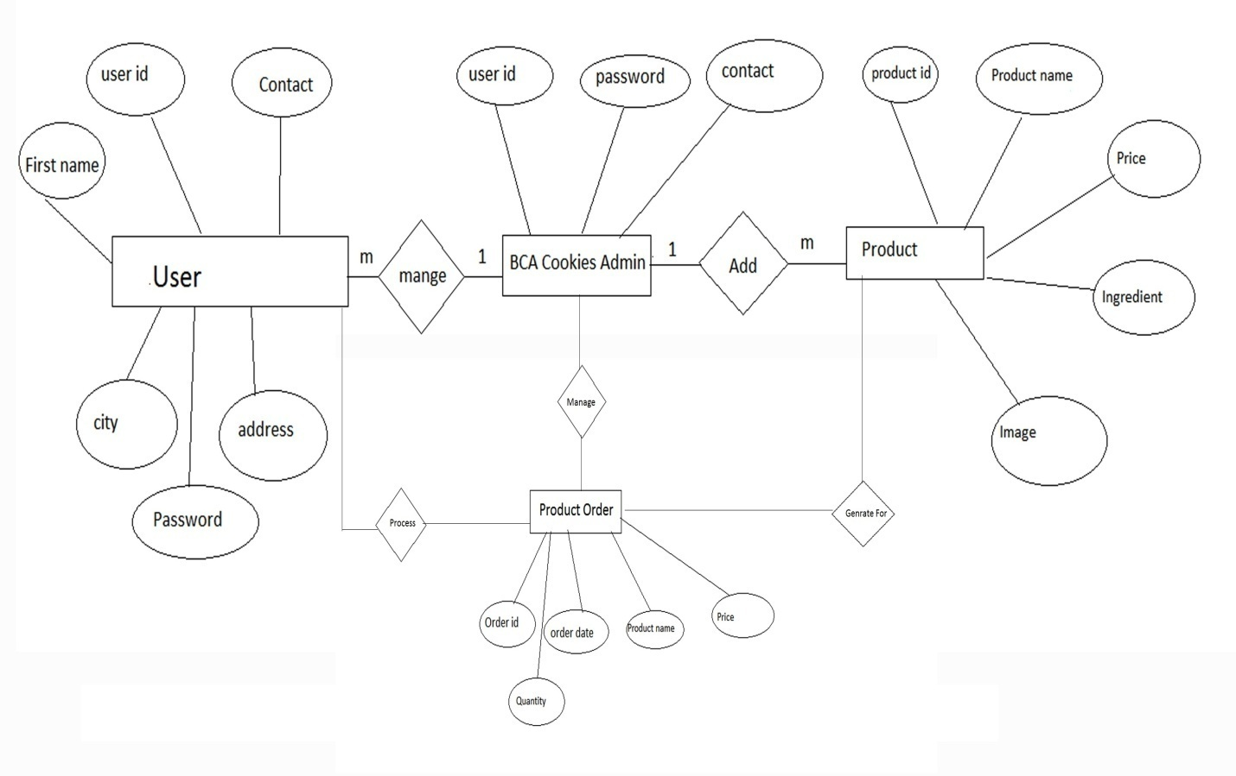

**Data Flow Diagram**

1. **Data Flow Diagram**

**8.1. Zero Level Diagram**

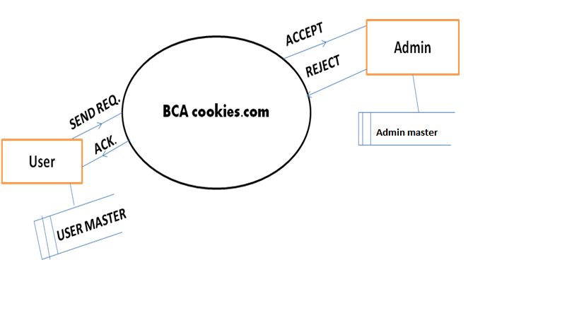

**1 Level Diagram**

Data Dictionary

1. **Data Dictionary**

After carefully understanding the requirements of the client the the entire data storage requirements are divided into tables. The below tables are normalized to avoid any anomalies during the course of data entry.

1. **Applied Tables**

**Login Table:**

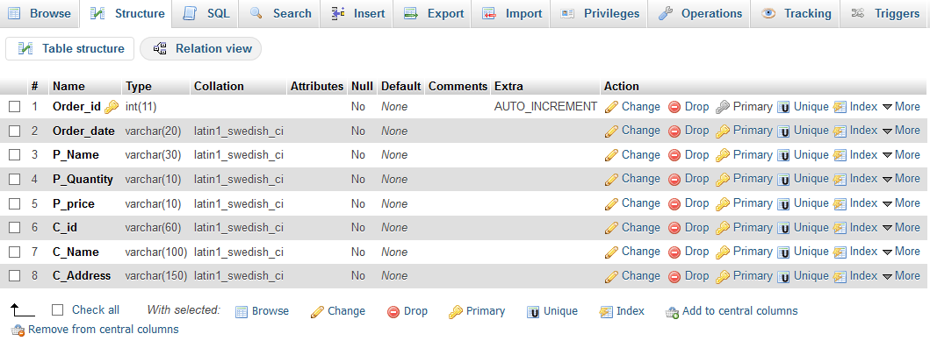

**Order:**



**Otp:**

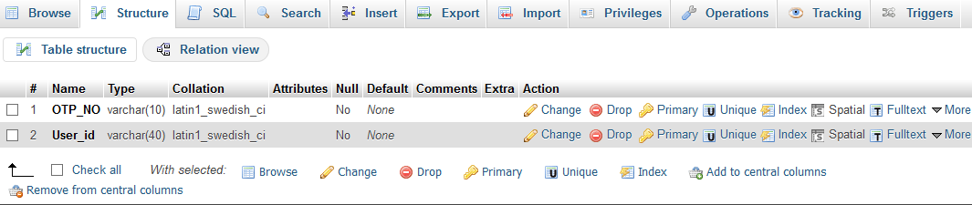

**Payment:**

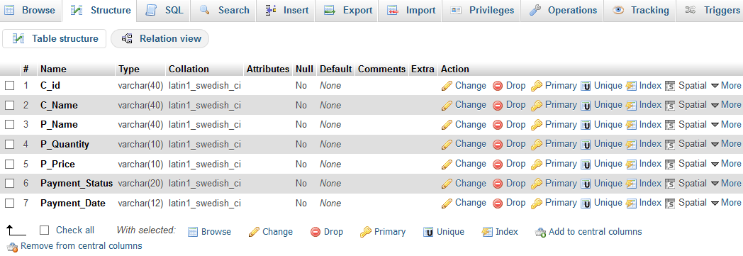

**Product:**

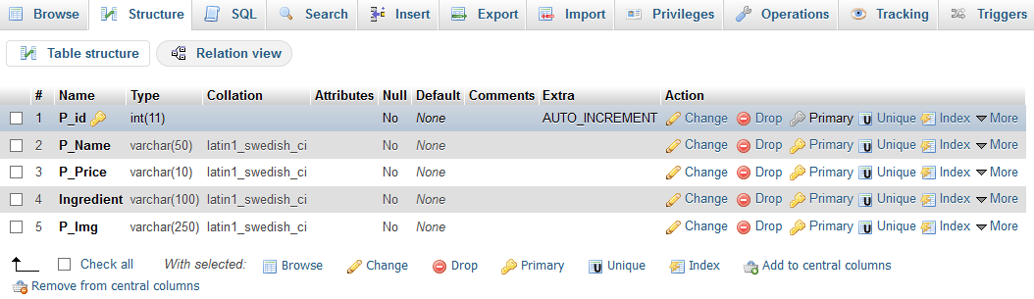

**Signup:**

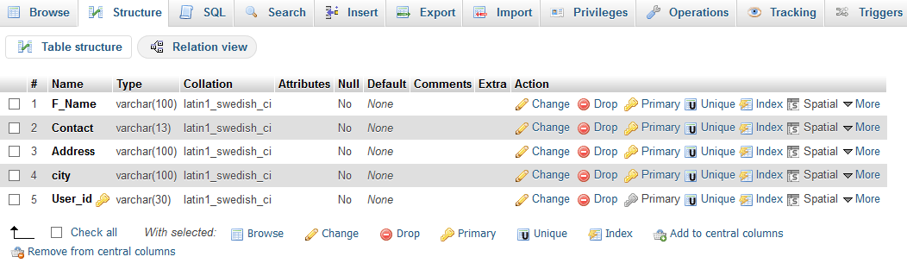

Screen Layout

**Home Page**

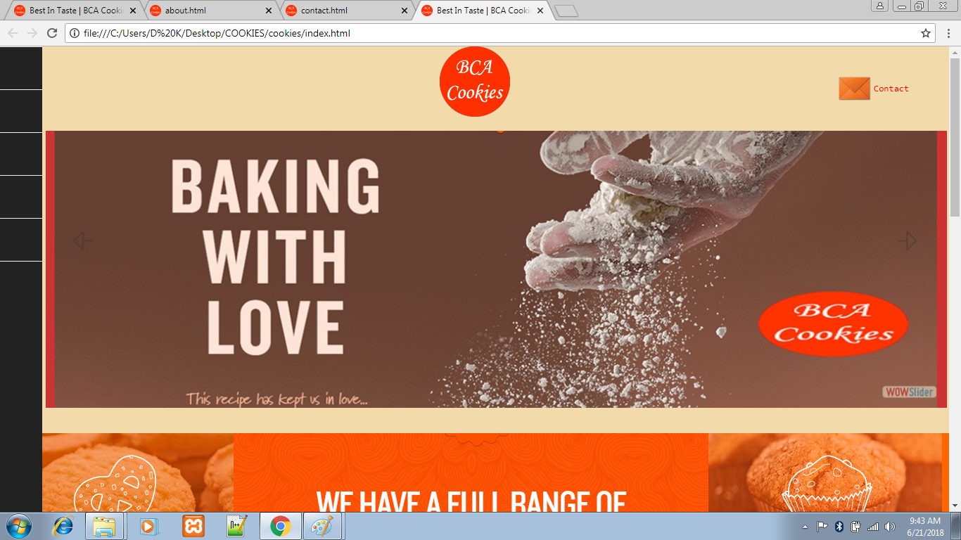

**About**

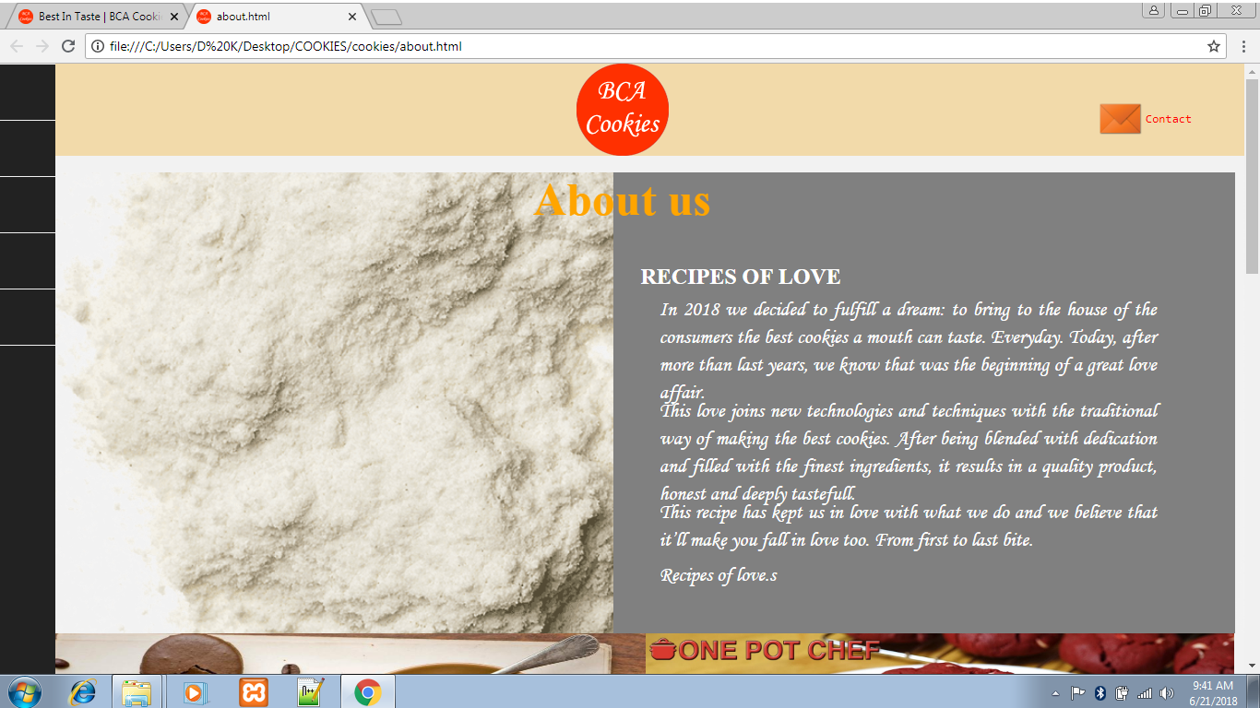

**Contact:**

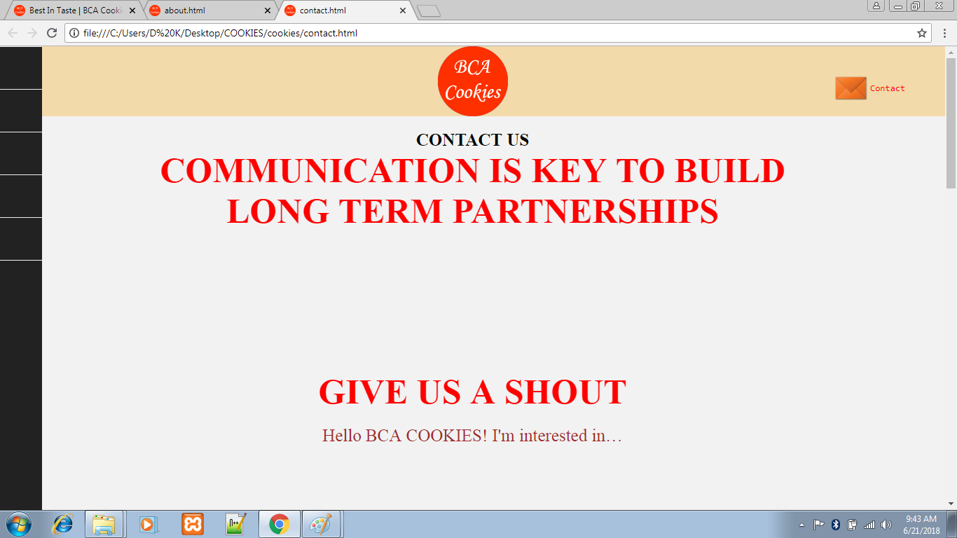

**Login**

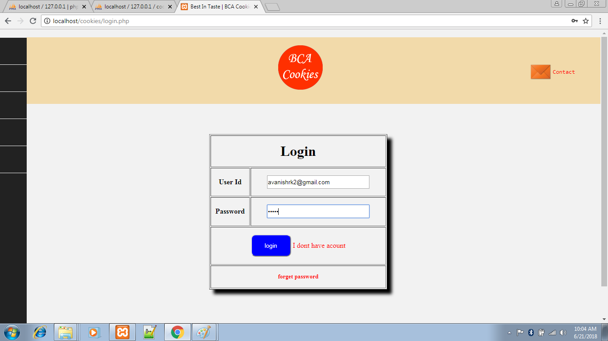

**Registration**

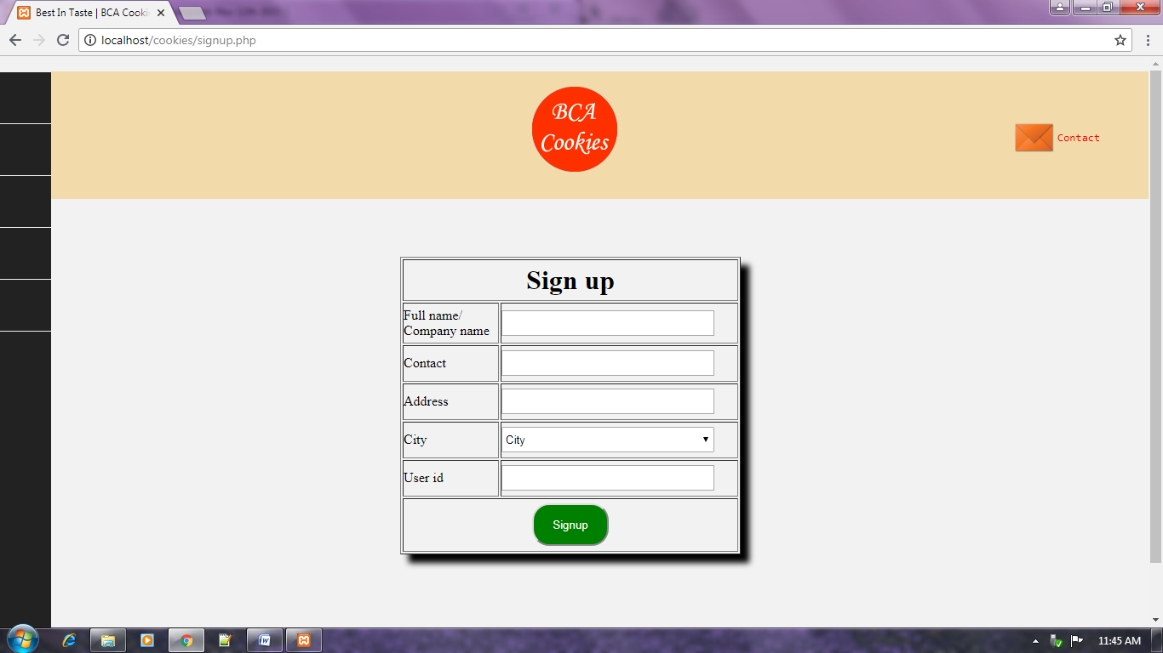

**Forget Password**

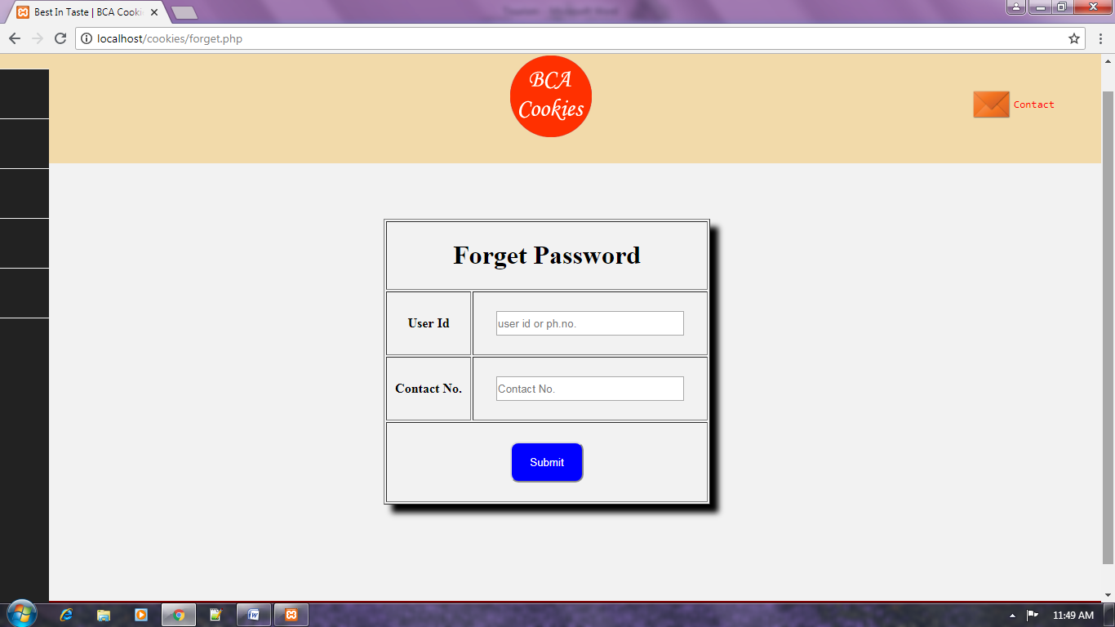

**Add Product**

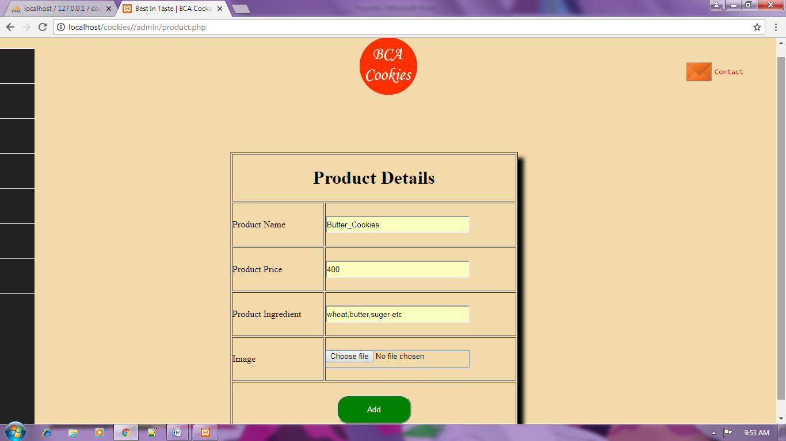

**Update Profile:**

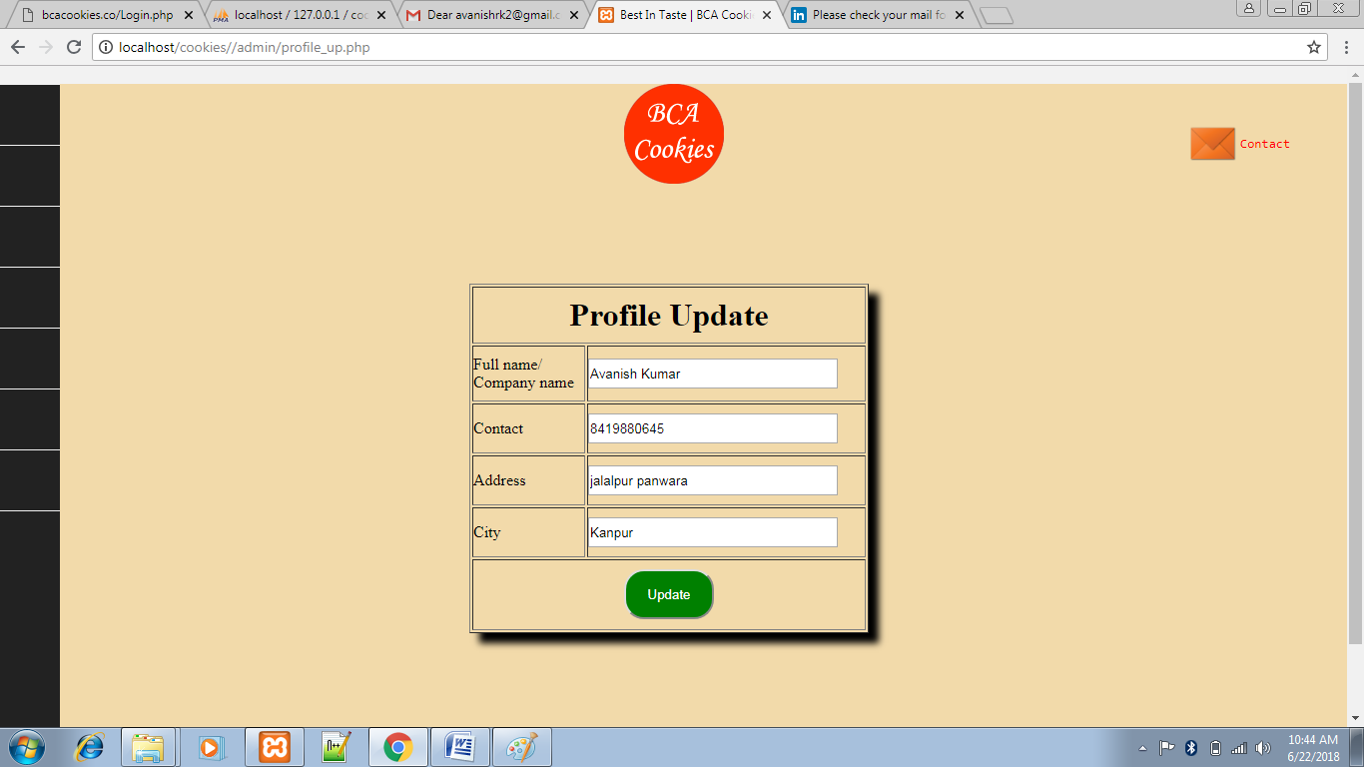

**View Order:**

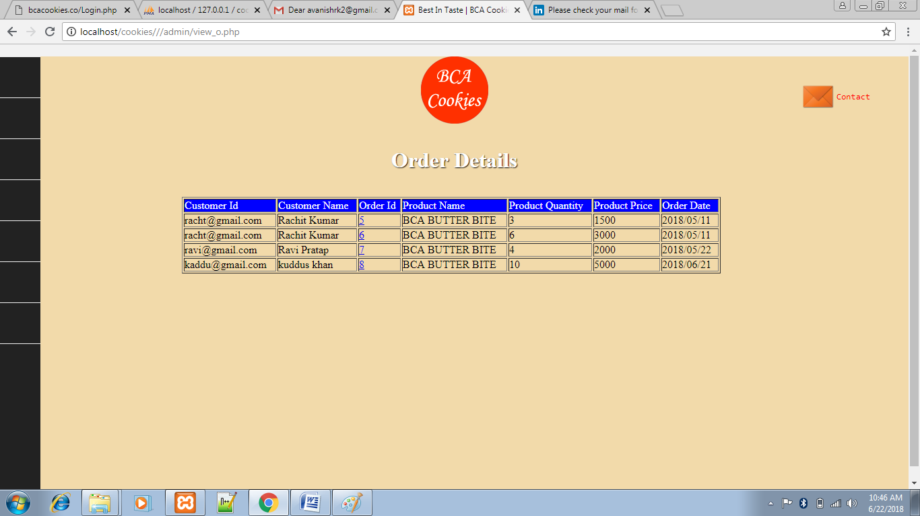

**Payment Detail:**

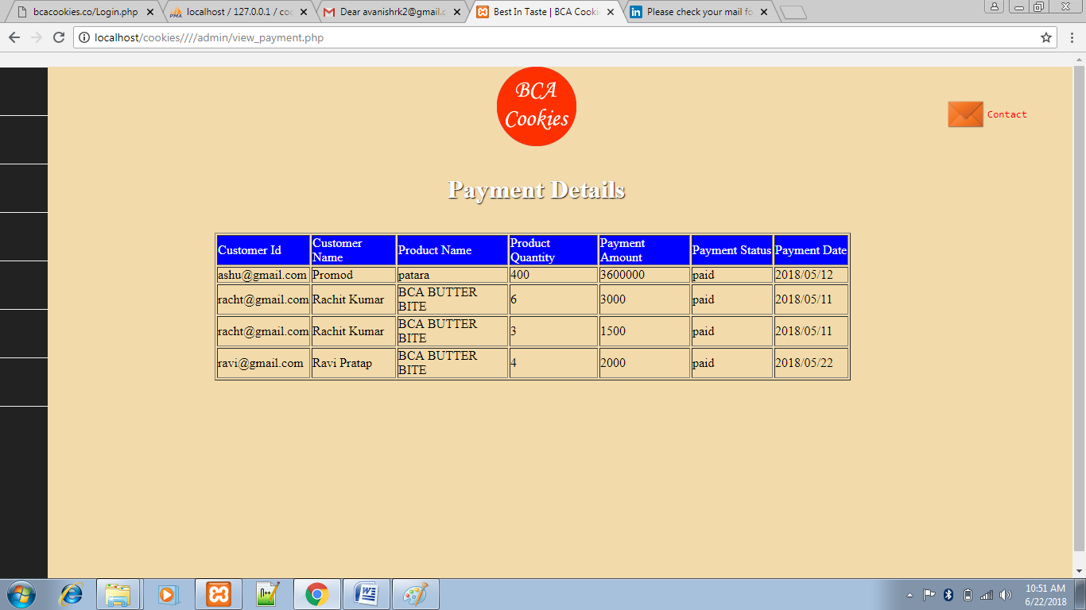

**View product:**

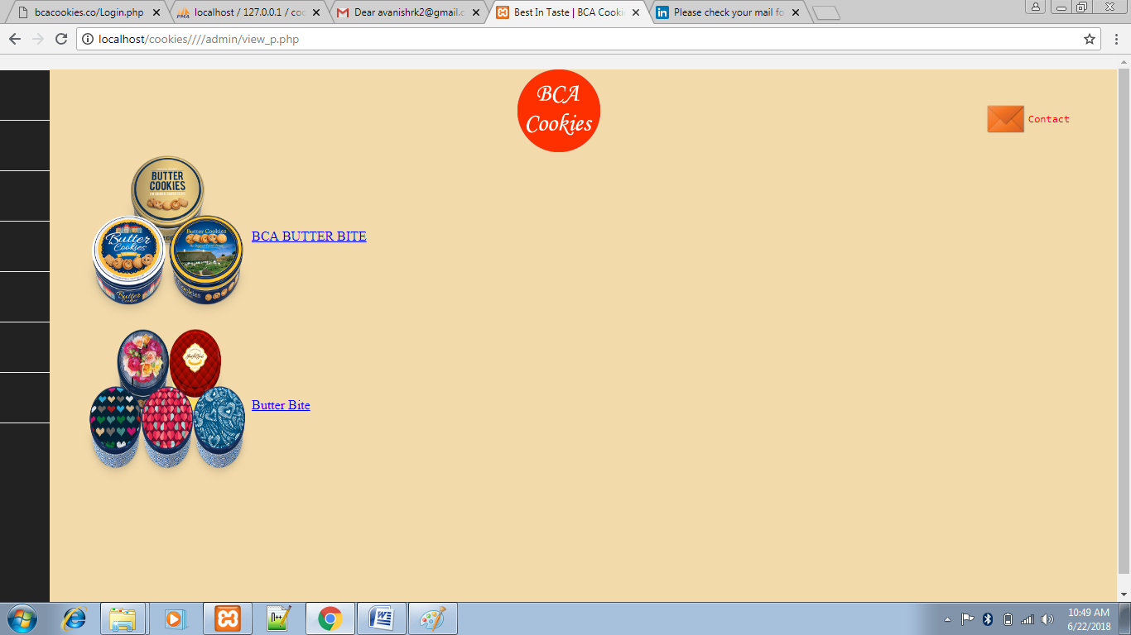

**Order**

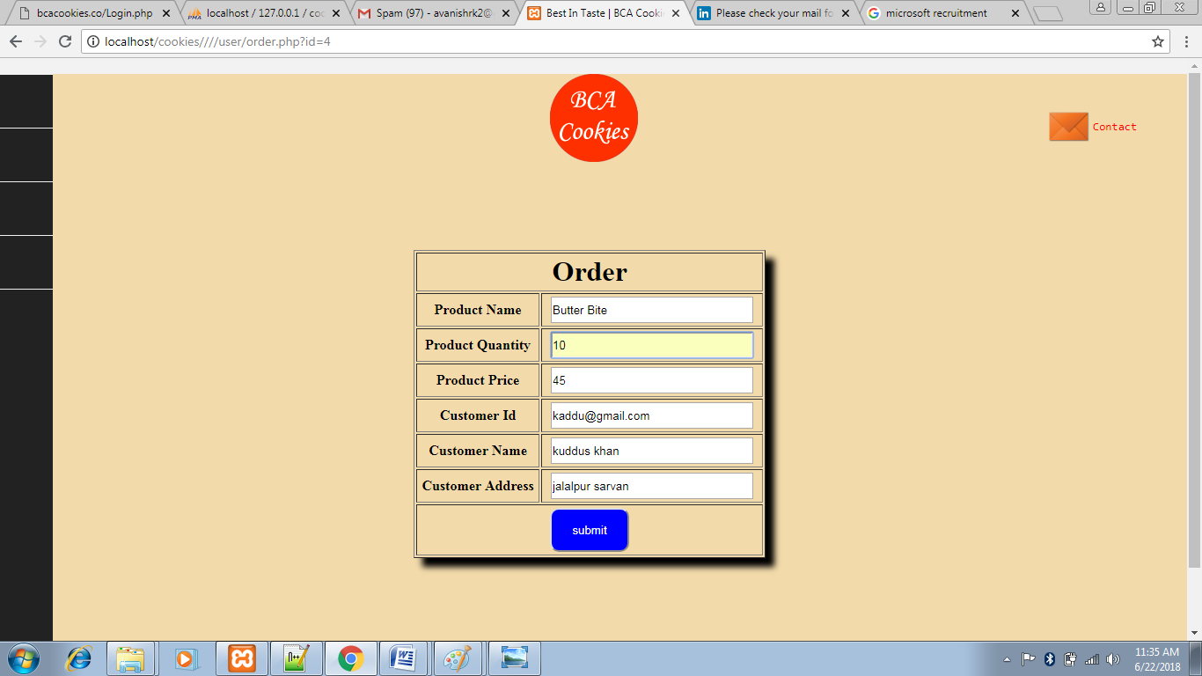

Coding

**Home Page:**

<html>

<head>

<title>Best In Taste | BCA Cookies</title>

<!-- Start WOWSlider.com HEAD section -->

<link rel="stylesheet" type="text/css" href="engine1/style.css" />

<script type="text/javascript" src="engine1/jquery.js"></script>

<!-- End WOWSlider.com HEAD section -->

<link rel='stylesheet prefetch' href='https://daneden.github.io/animate.css/animate.min.css'>

<link type="icon" rel="icon" href="logo.png"/>

<link rel="stylesheet" href="css/style.css">

<style>

.b{ text-align:center;color:white}

#wowslider-container1{ margin-left:65px; margin-top:20px;width:95%;}

#ggg{ background-color:F2DAAA; height:550px}

#second{background-color:FF6600;width:100%;height:70%;}

.third{background-color:#57c5c7; height:60%;width:100%;}

.third_img{height:100%;width:25%;}

#third_right{height:100%;width:50%; text-align:center; float:right;margin-top:-380px}

#third_right h3{color:white;font-size:40px; margin-top:80px}

#third_left{height:100%;width:50%; text-align:center;}

#third_left h3{color:white;font-size:40px; margin-top:80px}

#view_more{border-style:groove;color:white;border-radius:20px 20px;height:40px;width:300px;margin-left:30%;padding-top:25px;margin-top:50px}

#third_fourth{float:right;margin-top:-432px; width:50%;height:100%}

#third_fourth img{height:100%;width:100%}

#j{width:100%;height:26px;background-color:maroon;text-align:center;color:white;padding-top:10px;}

#j a{color:white;text-decoration:none}

#f h2{text-align:center;}

#cont{ float:right; margin-top:-5%; margin-right:4%; height:10%; color:#FF0000}

#cont pre{color:#FF0000}

#cont a{ text-decoration:none}

#cont img{height:50px; width:50px;}

</style>

</head>

<body>

<div>

<ul class="nav">

<li>

<i class="fa fa-home"></i>

<div class="animated bounceInLeft"><a href="index.html">Home</a></div>

</li>

<li>

<i class="fa fa-user"></i>

<div class="animated bounceInLeft"><a href="about.html">About</a></div>

</li>

<li>

<i class="fa fa-certificate"></i>

<div class="animated bounceInLeft"><a href="contact.html">Contact</a></div>

</li>

<li>

<i class="fa fa-desktop"></i>

<div class="animated bounceInLeft"><a href="product.html">Product<a></div>

</li>

<li>

<i class="fa fa-desktop"></i>

<div class="animated bounceInLeft"><a href="Login.php">Login</a></div>

</li>

</ul>

</div>

<div id="ggg">

<div>

<center>

<img src="logo.png"/>

</center>

<div id="cont">

<a href="contact.html">

<table>

<tr>

<td><img src="img/msg.png"/></td>

<td><pre>Contact</pre></td>

</tr>

</table>

</a>

</div>

</div>

<div id="wowslider-container1">

<div class="ws_images">

<ul>

<li><img src="data1/images/b!.jpg" alt="B!" title="B!" id="wows1_0"/></li>

<li><img src="data1/images/b2.jpg" alt="B2" title="B2" id="wows1_1"/></li>

<li><img src="data1/images/b3.jpg" alt="slideshow javascript" title="B3" id="wows1_2"/></li>

<li><img src="data1/images/b4.jpg" alt="b4" title="b4" id="wows1_3"/></li>

</ul></div>

<div class="ws_shadow"></div>

</div>

<script type="text/javascript" src="engine1/wowslider.js"></script>

<script type="text/javascript" src="engine1/script.js"></script>

<!-- End WOWSlider.com BODY section -->

</div>

<div id="second">

<div>

<img src="img/p1.png"/>

</div>

</div>

<div class="third">

<div>

<img src="img/1g.png" class="third_img"/>

<img src="img/2g.jpg" class="third_img"/>

</div>

<div id="third_right">

<img src="img/3g.jpg"/>

<br>

<h3>YOUR PRODUCT PARTNER</h3>

<br>

<div id="view_more">

<a href="">View More</a>

</div>

</div>

</div>

<div class="third">

<br>

<br>

<div id="third_left">

<img src="img/a1.jpg"/>

<br>

<h3>YOUR PRODUCT PARTNER</h3>

<br>

<div id="view_more">

<a href="">View More</a>

</div>

</div>

<div id="third_fourth">

<img src="img/a3.jpg"/>

</div>

</div>

<div id="j">

<p>&copy Copyright & Design By <a href="">BCA Cookies</a></p>

</div>

</body>

</html>

**About**

<html>

<head>

<link rel='stylesheet prefetch' href='https://daneden.github.io/animate.css/animate.min.css'>

<link type="icon" rel="icon" href="logo.png"/>

<link rel="stylesheet" href="css/style.css">

<style>

.b{ text-align:center;color:white}

#ggg{background-color:F2DAAA;height}

.a{width:50%}

#about{background-image:url('img/bg.png');height:500px; background-size:cover; background-position:right;}

#hh{text-align:center; }

#hh h2{font-size:50px; color:orange}

#kk{ width:50%;text-align:justify;color:white;background-color:grey;height:400px;float:right;margin-right:10px;margin-top:-58px;padding-top:100px}

#kk p{font-family:Monotype Corsiva;font-size:22px;line-height:30px;margin-top:-10px;width:80%;margin-left:50px}

#kk h2{margin-left:30px}

#pp{margin-left:45px}

#zz{ width:50%;text-align:justify;color:white;background-color:red;height:400px;margin-right:10px;padding-top:60px;margin-top:80px}

#zz p{font-family:Monotype Corsiva;font-size:30px;line-height:30px;margin-top:-10px;width:80%;margin-left:70px}

#kamla{margin-left:700; }

#kamla img{height:300px;width:638px}

#vimal{margin-top:-300px}

#vimal img{height:300;width:700px}

#yyy{font-size:20px;text-align:center;color:red;margin-top:50px}

#lll{margin-left:675px;margin-top:-460px}

#m1{height:380;width:350;}

#n1{height:180px;width:320px;font-size:20px;background-image:url('our.jpg');background-repeat:no-repeat;background-size:cover;TEXT-ALIGN:CENTER;PADDING-TOP:120PX;COLOR:WHITE;FONT-SIZE:20PX;margin-left:70px}

#o1{margin-top:-300px;margin-left:530px;height:180px;width:320px;font-size:15px;background-image:url('ypp.jpg');background-repeat:no-repeat;background-size:cover;TEXT-ALIGN:CENTER;PADDING-TOP:120PX;COLOR:WHITE;text-shadow:1px 1px 1px black;}

#p1{margin-top:-300px;margin-left:1000px;height:180px;width:320px;font-size:15px;background-image:url('contact us.jpg');background-repeat:no-repeat;background-size:cover;TEXT-ALIGN:CENTER;PADDING-TOP:120PX;COLOR:WHITE;text-shadow:1px 1px 1px black;}

#j{width:100%;height:25px;background-color:maroon;text-align:center;color:white;padding-top:10px;}

#j a{color:white;text-decoration:none}

#f h2{text-align:center;}

#cont{ float:right; margin-top:-5%; margin-right:4%; height:10%; color:#FF0000}

#cont pre{color:#FF0000}

#cont img{height:50px; width:50px;}

#cont a{ text-decoration:none}

</style>

</head>

<body>

<div>

<ul class="nav">

<li>

<i class="fa fa-home"></i>

<div class="animated bounceInLeft"><a href="index.html">Home</a></div>

</li>

<li>

<i class="fa fa-user"></i>

<div class="animated bounceInLeft"><a href="about.html">About</a></div>

</li>

<li>

<i class="fa fa-certificate"></i>

<div class="animated bounceInLeft"><a href="contact.html">Contact</a></div>

</li>

<li>

<i class="fa fa-desktop"></i>

<div class="animated bounceInLeft"><a href="product.html">Product</a></div>

</li>

<li>

<i class="fa fa-desktop"></i>

<div class="animated bounceInLeft"><a href="Login.php">Login</a></div>

</li>

</ul>

</div>

<div id="ggg">

<div>

<center>

<img src="logo.png"/>

</center>

</div>

<div id="cont">

<a href="contact.html">

<table>

<tr>

<td><img src="img/msg.png"/></td>

<td><pre>Contact</pre></td>

</tr>

</table>

</a>

</div>

</div>

<br/>

<div id="about">

<div id="hh">

<h2>About us</h2>

</div>

<div id="kk">

<h2>RECIPES OF LOVE</h2>

<br/>

<p>In 2018 we decided to fulfill a dream: to bring to the house of the consumers the best cookies a mouth can taste. Everyday. Today, after more than last years, we know that was the beginning of a great love affair.</p>

<p>

This love joins new technologies and techniques with the traditional way of making the best cookies. After being blended with dedication and filled with the finest ingredients, it results in a quality product, honest and deeply tastefull.</p>

<p>

This recipe has kept us in love with what we do and we believe that it’ll make you fall in love too. From first to last bite.

</p>

<br/>

<p>Recipes of love.s</p>

</div>

</div>

<div>

<div id="kamla">

<img src="img/a5.jpg">

</div>

<div id="vimal">

<img src="img/a6.jpg">

</div>

</div>

<div id="yyy">

<h1>OUR EXPERIANCE</h1>

</div>

<div id="zz">

<br/>

<p>

A Company with solid experience BCA COOKIES operates in the baking industry since 2018, producing and selling biscuits, cookies and other pastry products.</p>

<p>

We have 2 production facilities in India with 19 production lines, an installed capacity of 55 thousand tons, and we export to 30 city (75% of our production).

BCA COOKIES founded “Family Cookies Category” in India, maintaining the leadership until today.</p>

<p>

We are the second largest “Bca Butter Cookies” producer in India and the leading “cookies” producer in the India .

</p>

</div>

<div id="lll">

<img height="460px" width="674px"src="img/br.png">

</div>

</div>

<div id="m1">

<br></br>

<div id="n1">

<h1>OUR BRAND</h1>

</div>

<div id="o1">

<h1>YOUR PRODUCT PARTNER</h1>

</div>

<div id="p1">

<h1>CONTACT US</h1>

</div>

</div>

<div id="j">

<p>&copy Copyright & Design By <a href="">BCA Cookies</a></p>

</div>

</body>

</html>

**Contact**

<html>

<head>

<link rel='stylesheet prefetch' href='https://daneden.github.io/animate.css/animate.min.css'>

<link type="icon" rel="icon" href="logo.png"/>

<link rel="stylesheet" href="css/style.css">

<style>

#ggg{background-color:F2DAAA;}

#a{text-align:center;color:black;margin-top:20;font-size:25px}

.c{text-align:center;color:red;font-size:50px}

.d{text-align:center;color:red;margin-top:200;font-size:50px}

#e{text-align:center;color:brown;margin-top:20;font-size:25px}

#f{background-color:white;height:50;weight:50;text-align:center;margin-top:100;color:grey;padding-top:25}

#f li{display:inline;margin-left:40px}

.b{ text-align:center;color:white}

#k{text-align:center;height:263;weight:95}

#i{color:red}

#h{margin-left:500px;height:400;weight:300}

#h input{width:100%;height:90%}

#map{height:350;width:500;background-color:white;margin-top:-400px;margin-left:540px}

#j{height:350;width:500;background-color:red;text-color:white;padding-left:50px;padding-top:50px;}

#j H1{color:white;font-size:40px; margin-left:50px;}

#j p{color:white;font-size:26px;margin-top:20px;margin-left:50px;}

#l{height:350;width:490;background-color:red;text-color:white;padding-left:50px;padding-top:50px;margin-top:-400px;margin-left:800px}

#l H1{color:white;font-size:40px}

#l p{color:white;font-size:26px;margin-top:20px}

#kal{height:350;width:800;background-color:white}

#m{height:350;width:350;background-image:url("img1.PNG")}

#n{height:180px;width:320px;font-size:20px;background-image:url('our.jpg');background-repeat:no-repeat;background-size:cover;TEXT-ALIGN:CENTER;PADDING-TOP:120PX;COLOR:WHITE;FONT-SIZE:20PX;margin-left:70px}

#o{margin-top:-300px;margin-left:530px;height:180px;width:320px;font-size:15px;background-image:url('ypp.jpg');background-repeat:no-repeat;background-size:cover;TEXT-ALIGN:CENTER;PADDING-TOP:120PX;COLOR:WHITE;text-shadow:1px 1px 1px black;}

#p{margin-top:-300px;margin-left:1000px;height:180px;width:320px;font-size:15px;background-image:url('contact us.jpg');background-repeat:no-repeat;background-size:cover;TEXT-ALIGN:CENTER;PADDING-TOP:120PX;COLOR:WHITE;text-shadow:1px 1px 1px black;}

#ggg{background-color:F2DAAA;}

#z{width:100%;height:26px;background-color:maroon;text-align:center;color:white;padding-top:10px;}

#z a{color:white;text-decoration:none}

#z h2{text-align:center;}

#cont{ float:right; margin-top:-5%; margin-right:4%; height:10%; color:#FF0000}

#cont pre{color:#FF0000}

#cont img{height:50px; width:50px;}

#cont a{ text-decoration:none}

</style>

</head>

<body>

<div>

<ul class="nav">

<li>

<i class="fa fa-home"></i>

<div class="animated bounceInLeft"><a href="index.html">Home</a></div>

</li>

<li>

<i class="fa fa-user"></i>

<div class="animated bounceInLeft"><a href="about.html">About</a></div>

</li>

<li>

<i class="fa fa-certificate"></i>

<div class="animated bounceInLeft"><a href="contact.html">Contact</a></div>

</li>

<li>

<i class="fa fa-desktop"></i>

<div class="animated bounceInLeft"><a href="product.html">Product</a></div>

</li>

<li>

<i class="fa fa-desktop"></i>

<div class="animated bounceInLeft"><a href="Login.php">Login</a></div>

</li>

</ul>

</div>

</div>

<div id="ggg"><center>

<img src="logo.png"/></center>

<div id="cont">

<a href="contact.html">

<table>

<tr>

<td><img src="img/msg.png"/></td>

<td><pre>Contact</pre></td>

</tr>

</table>

</a>

</div>

</div>

<div>

<h5 id="a">CONTACT US</h5>

<h1 class="c">COMMUNICATION IS KEY TO BUILD</h1>

<h1 class="c"> LONG TERM PARTNERSHIPS</h1>

<h1 class="d">GIVE US A SHOUT</h1>

<p id="e">Hello BCA COOKIES! I'm interested in…</p>

</div>

<div class="credits">

<a href="https://twitter.com/arximughal"><i class="fa fa-twitter"></i></a>

<a href="https://facebook.com/arximughal"><i class="fa fa-facebook"></i></a>

<a href="https://arslanaslam.me"><i class="fa fa-globe"></i></a>

</div>

<div id="f">

<ul>

<li>BUY YOUR PRODUCTS</li>

<li>BE YOUR SUPPLIER</li>

<li>WORK IN BCA COOKIES</li>

<li>OTHER</li>

</ul>

</div>

<div>

<table id="h">

<tr>

<td colspan="2">

<input type="text" placeholder="Your Name"/>

</td>

</tr>

<tr>

<td colspan="2">

<input type="text" placeholder="Your email"/>

</td>

</tr>

<tr>

<td>

<input type="text" placeholder="Phone"/>

</td>

<td>

<input type="text" placeholder="Country"/>

</td>

</tr>

<tr>

<td colspan="2">

<input type="text" placeholder="Message"/>

</td>

</tr>

<tr >

<td align="center" colspan="2" >

<input type="submit"value="SEND" id="i"/>

</td>

</tr>

</table>

</div>

<div id="J">

<h1>HEAD OFFICE</h1>

<br>

<p>BCA COOKIES</p>

<p>NEAR BHINDURI POLICE STATION </p>

<p>CONTACT: 9236564894</p>

</div>

<div id="map">

<iframe src="https://www.google.com/maps/embed?pb=!1m18!1m12!1m3!1d3566.7917983469138!2d80.17851751462901!3d26.623119583253146!2m3!1f0!2f0!3f0!3m2!1i1024!2i768!4f13.1!3m3!1m2!1s0x399c3218e8514803%3A0x65055ae107e176a5!2sSaaii+College+of+Medical+Science+%26+Technology!5e0!3m2!1sen!2sin!4v1519381149168" width="800" height="350" frameborder="0" style="border:0" allowfullscreen></iframe>

</div>

<div id="kal">

<iframe src="https://www.google.com/maps/embed?pb=!1m18!1m12!1m3!1d1785.2636296971355!2d80.25042571462602!3d26.503161983305745!2m3!1f0!2f0!3f0!3m2!1i1024!2i768!4f13.1!3m3!1m2!1s0x399c37a219d2cb13%3A0x300b4b5e8fe52036!2sSatyam+Sweets!5e0!3m2!1sen!2sin!4v1519381331860" width="800" height="350" frameborder="0" style="border:0" allowfullscreen></iframe>

</div>

<div id="l">

<h1>BRANCH OFFICE</h1>

<p>BCA COOKIES</p>

<p>KALYANPUR</p>

<p>CONTACT: 9648149728 </p>

</div>

<div id="m">

<div id="n">

<h1>OUR BRAND</h1>

</div>

<div id="o">

<h1>YOUR PRODUCT PARTNER</h1>

</div>

<div id="p">

<h1>CONTACT US</h1>

</div>

</div>

<div id="z">

<p>&copy Copyright & Design By <a href="">BCA Cookies</a></p>

</div>

</body>

</html>

**Product**

<html>

<head>

<link rel='stylesheet prefetch' href='https://daneden.github.io/animate.css/animate.min.css'>

<link type="icon" rel="icon" href="logo.png"/>

<link rel="stylesheet" href="css/style.css">

<style>

#ggg{background-color:F2DAAA;height}

#a{text-align:center}

#a h1{color:red;font-weight:bold;padding-top:50px;font-size:50px}

#a p{font-size:30px;padding-top:30px;font-family:Lucida Calligraphy;width:800px;color:#6f5f4a}

#b{text-align:center}

#b h1{color:#825215;font-weight:bold;padding-top:50px;font-size:50px}

#b p{font-size:10px;padding-top:30px;font-family:Lucida Calligraphy;width:800px;color:gray}

#f{height:300px;width:97%;margin-top:100px;margin-left:40px}

#c img{height:300px;width:400px;}

#c{margin-left:50px;height:300px;width:350px;}

#d{margin-left:500px;margin-top:-300px;height:300px;width:350px;}

#d img{height:300px;width:400px;}

#e img{height:300px;width:400px;}

#e{margin-left:900px;margin-top:-300px;height:300px;width:350px;}

#g img{height:300px;width:350px;}

#g{margin-left:60px;height:300px;width:350px;}

#h{margin-left:510px;margin-top:-300px;height:300px;width:350px;}

#h img{height:300px;width:350px;}

#i img{height:300px;width:350px;}

#i{margin-left:910px;margin-top:-300px;height:300px;width:350px;}

#j{width:100%;margin-top:400px;height:25px;background-color:maroon;text-align:center;color:white;padding-top:10px;}

#j a{color:white;text-decoration:none}

#f h2{text-align:center;}

#cont{ float:right; margin-top:-5%; margin-right:4%; height:10%; color:#FF0000}

#cont pre{color:#FF0000}

#cont img{height:50px; width:50px;}

#cont a{ text-decoration:none}

</style>

</head>

<body>

<div>

<ul class="nav">

<li>

<i class="fa fa-home"></i>

<div class="animated bounceInLeft"><a href="index.html">Home</a></div>

</li>

<li>

<i class="fa fa-user"></i>

<div class="animated bounceInLeft"><a href="about.html">About</a></div>

</li>

<li>

<i class="fa fa-certificate"></i>

<div class="animated bounceInLeft"><a href="contact.html">Contact</a></div>

</li>

<li>

<i class="fa fa-desktop"></i>

<div class="animated bounceInLeft"><a href="product.html">Product</a></div>

</li>

<li>

<i class="fa fa-desktop"></i>

<div class="animated bounceInLeft"><a href="Login.php">Login</a></div>

</li>

</ul>

</div>

<div id="ggg">

<div>

<center>

<img src="logo.png"/>

</center>

</div>

<div id="cont">

<a href="contact.html">

<table>

<tr>

<td><img src="img/msg.png"/></td>

<td><pre>Contact</pre></td>

</tr>

</table>

</a>

</div>

</div>

<div id="a">

<h1>PRODUCT</h1>

<center>

<p>We are Indian producer of quality bekery

pruducts with worldwide presence

</p>

</center>

</div>

<div id="b">

<h1>BUTTER COOKIES</h1>

<center>

<p>Our Butter Cookies are made with the traditional BCA recipe that is in the top of mind of our consumers since always. The attractive tins and boxes design make this product perfect to offer to someone special or only to collect. Available in different recipes, you just have to choose yours!

</p>

</center>

</div>

<div id="f">

<div id="c">

<img src="img/product/z1.png"/>

<h2>COLLECTION</h2>

</div>

<div id="d">

<img src="img/product/z2.png"/>

<h2>LOVE COLLECTION</h2>

</div>

<div id="e">

<img src="img/product/z4.png"/>

<h2>CHRISTMAS</h2>

</div></br></br></br></br>

<div id="g">

<img src="img/product/z3.jpg"/>

<h2>BREAKFAST COLLECTION</h2>

</div>

<div id="h">

<img src="img/product/z8.jpg"/>

<h2>CELEBRATION DAY</h2>

</div>

<div id="i">

<img src="img/product/z9.jpg"/>

<h2>PAPER BOX</h2>

</div>

</div>

<div id="j">

<p>&copy Copyright & Design By <a href="">BCA Cookies</a></p>

</div>

</body>

</html>

**Login**

<?php

session_start();

if(isset($_POST['login']))

{

include("connect.php");

$em=$_POST['ui'];

$pw=$_POST['pw'];

$sql="select User_type from login where User_id='$em' and Password='$pw'";

$result=mysqli_query($con,$sql);

if(mysqli_num_rows($result)>0)

{

while($ow=mysqli_fetch_assoc($result))

{

$ut=$ow['User_type'];

if($ut=="admin")

{

$_SESSION['em']=$_POST['ui'];

header("location:admin/profile.php");

}

else if($ut=="Customer")

{

$_SESSION['em']=$_POST['ui'];

header("location:user/profile_up.php");

}

}

}

else

{

echo"<script>alert('User id and passsword does not match');</script>";

}

}

?>

<html>

<head>

<style>

.a{height:30px;width:230px}

#b{margin-top:100px;box-shadow:10px 10px 10px black;margin-left:470px}

#c{height:50px;width:90px;background-color:blue;color:white;border-radius:10px 10px}

.m{color:red;text-decoration:none}

#l{height:100px}

</style>

</head>

<body>

<?php

include("header.php");

?>

<form method="POST">

<table id="b" border="1" height="350px" width="400px" align="center">

<tr>

<td colspan="2" align="center">

<h1>

Login

</h1>

</td>

</tr>

<tr>

<td align="center">

<h4>

User Id

</h4>

</td>

<td align="center">

<input type="text" class="a" placeholder ="user id or ph.no." name="ui"/ >

</td>

</tr>

<tr>

<td align="center">

<h4>Password</h4>

</td>

<td align="center">

<input type="password" class="a" placeholder ="password" name="pw"/ >

</td>

</tr>

<tr>

<td colspan="2"align="center" >

<input type="submit" value="login" id="c" name="login"/>

<a href="signup.php"class="m"> I dont have acount</a>

</td>

</tr>

<tr>

<td colspan="2"align="center">

<h5>

<a href="forget.php" class="m"> forget password</a>

</h5>

</tr>

</td>

</tr>

</table>

<div id="l"></div>

<?php

include("footer.php");?>

</form>

</body>

</html>

**Signup:**

<?php

if(isset($_POST['ff']))

{

include("connect.php");

$fn=$_POST['fn'];

$cont=$_POST['cn'];

$add=$_POST['ad'];

$ct=$_POST['ct'];

$uid=$_POST['ui'];

$ut="Customer";

$pass=rand(1000,10000);

$query="insert into login(user_id,password,user_type) values('$uid','$pass','$ut');";

$query.="insert into sign_up(F_Name,Contact,Address,city,User_id) values('$fn','$cont','$add','$ct','$uid');";

mysqli_multi_query($con,$query) or die("<script>alert('Resistration Failed');</script>");

echo"<script>alert('Resistration Successfully Done');</script>";

$msg="Dear ".$fn.",You Have Successfully Resister In BCA Cookies. Your User id=".$uid." and Password=".$pass;

$ch = curl_init();

$user="rocksuchindrakumar@gmail.com:johnrandy";

$senderID="TEST SMS";

curl_setopt($ch,CURLOPT_URL, "http://api.mVaayoo.com/mvaayooapi/MessageCompose");

curl_setopt($ch, CURLOPT_RETURNTRANSFER, 1);

curl_setopt($ch, CURLOPT_POST, 1);

curl_setopt($ch, CURLOPT_POSTFIELDS, "user=$user&senderID=$senderID&receipientno=$cont&msgtxt=$msg");

$buffer = curl_exec($ch);

if(empty ($buffer))

{ echo " buffer is empty "; }

else

{ }

curl_close($ch);

}

?>

<html>

<head>

<style>

#a{width:150px;}

#b{width:400px;height:350px;margin-top:100px;box-shadow:10px 10px 10px black;margin-left:470px}

.c{width:250px;height:30px;}

#d{color:white;background-color:green;height:50px;width:90px;border-radius:20px 20px}

#l{height:100px}

</style>

</head>

<body>

<?php include("header.php");

?>

<form method="POST">

<table id="b" border="1"= align="center">

<tr>

<td colspan="2" align="center">

<h1>Sign up</h1>

</td>

</tr>

<tr>

<td>Full name/<br>Company name</td>

<td><input type="text"class="c"name="fn"/></td>

</tr>

<tr>

<td>Contact</td>

<td><input type="text"class="c"name="cn"/></td>

<tr>

<td>Address</td>

<td><input type="text"class="c"name="ad"/></td>

</tr>

<tr>

<td>City</td>

<td>

<select class="c"name="ct">

<option>City</option>

<option value="Kanpur">Kannauj</option>

<option value="Kanpur">Kanpur</option>

<option value="Kanpur">Lucknow</option>

<option value="Kanpur">Farrukhabad</option>

<option value="Kanpur">Kanpur Dehat</option>

<option value="Kanpur">Unnao</option>

<option value="Jhasi">Jhasi</option>

<option value="Delhi">Delhi</option>

<option value="Mumbai">Mumbai</option>

<option value="Chennai">Chennai</option>

<option value="Jaipur">Jaipur</option>

<option value="Surat">Surat</option>

<option value="Nagpur">Nagpur</option>

</select>

</td>

<tr>

<td>User id</td>

<td><input type="text" laceholder="user id"class="c"name="ui"/></td>

<tr>

<td colspan="2" align="center">

<input type="submit" value="Signup" id="d"name="ff"/>

</td>

</tr>

</table></form>

<div id="l"></div>

<?php

include("footer.php");

?>

</body>

</html>

**Forget Password**

<html>

<head>

<style>

.a{height:30px;width:230px}

#b{margin-top:100px;box-shadow:10px 10px 10px black;margin-left:470px}

#c{height:50px;width:90px;background-color:blue;color:white;border-radius:10px 10px}

.m{color:red;text-decoration:none}

#l{height:100px}

</style>

</head>

<body>

<?php

include("header.php");

?>

<form method="POST">

<table id="b" border="1" height="350px" width="400px" align="center">

<tr>

<td colspan="2" align="center">

<h1>

Forget Password

</h1>

</td>

</tr>

<tr>

<td align="center">

<h4>

User Id

</h4>

</td>

<td align="center">

<input type="text" class="a" placeholder ="user id or ph.no."/ >

</td>

</tr>

<tr>

<td align="center">

<h4>Contact No.</h4>

</td>

<td align="center">

<input type="text" class="a" placeholder ="Contact No."/ >

</td>

</tr>

<tr>

<td colspan="2"align="center" >

<input type="submit" value="Submit" id="c"/>

</td>

</tr>

</table>

<div id="l"></div>

<?php

include("footer.php");?>

</form>

</body>

</html>

**Add Product**

<?php

if(isset($_POST['sub']))

{

$tt="../upload/";

$tf=$tt.basename($_FILES["img"]["name"]);

$filetype=strtolower(pathinfo($tf,PATHINFO_EXTENSION));

$check = getimagesize($_FILES["img"]["tmp_name"]);

if(move_uploaded_file($_FILES["img"]["tmp_name"],$tf))

{

include("../connect.php");

$nm=$_POST['pn'];

$pp=$_POST['pp'];

$pi=$_POST['pi'];

$sql="insert into product(P_Name,P_Price,Ingredient,P_Img) values('$nm','$pp','$pi','$tf')";

mysqli_query($con,$sql) or die("<script>alert('Some Thing wrong');</script>");

echo"<script>alert('Product added successfully');</script>";

}

}

?>

<html>

<head>

<style>

#a{width:150px;}

#b{width:500px;height:500px;margin-top:100px;box-shadow:10px 10px 10px black;margin-left:400px}

.c{width:250px;height:30px;}

#d{color:white;background-color:green;height:50px;width:130px;border-radius:20px 20px}

</style>

</head>

<body>

<?php include("header.php");?>

<form method="POST" enctype="multipart/form-data">

<table id="b" border="1">

<tr>

<td colspan="2" align="center">

<h1>Product Details</h1>

</td>

</tr>

<tr>

<td>Product Name</td>

<td><input type="text" class="c" name="pn"/></td>

</tr>

<tr>

<td>Product Price</td>

<td><input type="text"class="c" name="pp"/></td>

<tr>

<td>Product Ingredient</td>

<td><input type="text"class="c" name="pi"/></td>

</tr>

<tr>

<td>Image</td>

<td><input type="file"class="c" name="img"/></td>

<tr>

<td colspan="2" align="center">

<input type="submit" value="Add" id="d" name="sub"/>

</td>

</tr>

</table>

</form>

</body>

</html>

**Update Profile**

<?php

session_start();

$em=$_SESSION['em'];

include("../connect.php");

$sele="select F_Name,Contact,Address,city from sign_up where User_id='$em'";

$res=mysqli_query($con,$sele);

if(mysqli_num_rows($res)>0)

{

while($row=mysqli_fetch_assoc($res))

{

$nm=$row['F_Name'];

$cn=$row['Contact'];

$ad=$row['Address'];

$ci=$row['city'];

}

}

if(isset($_POST['ff']))

{

include("../connect.php");

$fn=$_POST['fn'];

$cont=$_POST['cn'];

$add=$_POST['ad'];

$ct=$_POST['ct'];

$query="update sign_up set F_Name='$fn', Contact='$cont',Address='$add',city='$ct' where User_id='$em'";

mysqli_query($con,$query) or die("<script>alert('Updation Failed');</script>");

echo"<script>alert('You have Successfully Updated Your Profile');</script>";

}

?>

<html>

<head>

<style>

#a{width:150px;}

#b{width:400px;height:350px;margin-top:100px;box-shadow:10px 10px 10px black;margin-left:470px}

.c{width:250px;height:30px;}

#d{color:white;background-color:green;height:50px;width:90px;border-radius:20px 20px}

#l{height:100px}

</style>

</head>

<body>

<?php include("header.php");

?>

<form method="POST">

<table id="b" border="1"= align="center">

<tr>

<td colspan="2" align="center">

<h1>Profile Update</h1>

</td>

</tr>

<tr>

<td>Full name/<br>Company name</td>

<td><input type="text"class="c"name="fn" value="<?php if(isset($nm)) echo $nm;?>"/></td>

</tr>

<tr>

<td>Contact</td>

<td><input type="text"class="c"name="cn" value="<?php if(isset($cn)) echo $cn;?>"/></td>

<tr>

<td>Address</td>

<td><input type="text"class="c"name="ad" value="<?php if(isset($ad)) echo $ad;?>"/></td>

</tr>

<tr>

<td>City</td>

<td>

<input type="text"class="c"name="ct" value="<?php if(isset($ci)) echo $ci;?>"/>

</td>

<tr>

<td colspan="2" align="center">

<input type="submit" value="Update" id="d"name="ff"/>

</td>

</tr>

</table></form>

<div id="l"></div>

<?php

include("footer.php");

?>

</body>

</html>

**View Order**

<?php

session_start();

$em=$_SESSION['em'];

?>

<html>

<head>

<style>

#kk{margin-left:270px;width:800px;}

#col{background-color:blue;color:white}

#gg{text-align:center;color:white;text-shadow:1px 1px 1px black}

</style>

</head>

<body><?php

include("header.php");

?>

<?php

include("../connect.php");

$sql="select C_id,C_Name,Order_id,P_Name,P_Quantity,P_price,Order_date from orderrr";

$re=mysqli_query($con,$sql);

if(mysqli_num_rows($re)>0)

{

echo"

<br/>

<br/>

<h1 id=gg>Order Details</h1>

<br>

<br/>

<table border=1 id=kk>

<tr id=col>

<td>Customer Id</td>

<td>Customer Name</td>

<td>Order Id</td>

<td>Product Name</td>

<td>Product Quantity</td>

<td>Product Price</td>

<td>Order Date</td>

</tr>";

while($ro=mysqli_fetch_assoc($re))

{

echo"

<tr>

<td><p>".$ro['C_id']."</p></td>

<td><p>".$ro['C_Name']."</p></td>

<td><a href=payment.php?id=".$ro['Order_id'].">".$ro['Order_id']."</a></td>

<td><p>".$ro['P_Name']."</p></td>

<td><p>".$ro['P_Quantity']."</p></td>

<td><p>".$ro['P_price']."</p></td>

<td><p>".$ro['Order_date']."</p></td>

</tr>";

}

}

"

</table>";

?>

</body>

</html>

**Payment Detail**

<html>

<head>

<style>

#kk{margin-left:270px;width:800px;}

#col{background-color:blue;color:white}

#gg{text-align:center;color:white;text-shadow:1px 1px 1px black}

</style>

</head>

<body><?php

include("header.php");

?>

<?php

include("../connect.php");

$sql="select C_id,C_Name,P_Name,P_Quantity,P_Price,Payment_Status,Payment_Date from payment";

$re=mysqli_query($con,$sql);

if(mysqli_num_rows($re)>0)

{

echo"

<br/>

<br/>

<h1 id=gg>Payment Details</h1>

<br>

<br/>

<table border=1 id=kk>

<tr id=col>

<td>Customer Id</td>

<td>Customer Name</td>

<td>Product Name</td>

<td>Product Quantity</td>

<td>Payment Amount</td>

<td>Payment Status</td>

<td>Payment Date</td>

</tr>";

while($ro=mysqli_fetch_assoc($re))

{

echo"

<tr>

<td><p>".$ro['C_id']."</p></td>

<td><p>".$ro['C_Name']."</p></td>

<td><p>".$ro['P_Name']."</p></td>

<td><p>".$ro['P_Quantity']."</p></td>

<td><p>".$ro['P_Price']."</p></td>

<td><p>".$ro['Payment_Status']."</p></td>

<td><p>".$ro['Payment_Date']."</p></td>

</tr>";

}

}

"

</table>";

?>

</body>

</html>

**View Product**

<html>

<head>

<style>

#kk{margin-left:100px}

</style>

</head>

<body>

<?php

include("header.php");

?>

<?php

include("../connect.php");

$sql="select P_id,P_Name,P_Img from product";

$re=mysqli_query($con,$sql);

if(mysqli_num_rows($re)>0)

{

while($ro=mysqli_fetch_assoc($re))

{

echo"<table id=kk><tr><td><img src=".$ro['P_Img']." height=200px width=200px /></td> <td><a href=specification.php?id=".$ro['P_id'].">".$ro['P_Name']." </a></td></tr></table>";

}

}

?>

</body>

</html>

**Customer Order**

<?php

session_start();

$pid=$_REQUEST['id'];

$em=$_SESSION['em'];

include("../connect.php");

$sql="select P_Name,P_Price from product where P_id='$pid';";

$res=mysqli_query($con,$sql);

if(mysqli_num_rows($res)>0)

{

while($ro=mysqli_fetch_assoc($res))

{

$pn=$ro['P_Name'];

$pp=$ro['P_Price'];

}

$sql1="select F_Name,Address FROM sign_up where User_id='$em';";

$res1=mysqli_query($con,$sql1);

if(mysqli_num_rows($res1)>0)

{

while($ro1=mysqli_fetch_assoc($res1))

{

$cn=$ro1['F_Name'];

$ad=$ro1['Address'];

}

}

}

if(isset($_POST['sub']))

{

include("../connect.php");

$date=date('Y/m/d');

$pname=$_POST['pname'];

$pprice=$_POST['pprice'];

$pq=$_POST['pq'];

$cid=$_POST['cid'];

$cnm=$_POST['cnm'];

$ad=$_POST['add'];

$tp=$pprice*$pq;

$sql12="insert into orderrr(Order_date,P_Name,P_price,P_Quantity,C_id,C_Name,C_Address) values('$date','$pname','$tp','$pq','$cid','$cnm','$ad')";

mysqli_query($con,$sql12) or die('<script>alert("order details is not submitted ")</script>');

$_SESSION['em']=$_POST['cid'];

header("location:view_o.php");

}

?>

<html>

<head>

<style>

.a{height:30px;width:230px}

#b{margin-top:100px;box-shadow:10px 10px 10px black;margin-left:470px}

#c{height:50px;width:90px;background-color:blue;color:white;border-radius:10px 10px}

.m{color:red;text-decoration:none}

#l{height:100px}

</style>

</head>

<body>

<?php

include("header.php");

?>

<form method="POST">

<table id="b" border="1" height="350px" width="400px" align="center">

<tr>

<td colspan="2" align="center">

<h1>Order

</h1>

</td>

</tr>

<tr>

<td align="center">

<h4>

Product Name

</h4>

</td>

<td align="center">

<input type="text" class="a" placeholder" name="pname" value="<?php if(isset($pn)) echo $pn;?>"/ >

</td>

</tr>

<tr>

<td align="center">

<h4> Product Quantity</h4>

</td>

<td align="center">

<input type="text" class="a" name="pq" placeholder"/ >

</td>

</tr>

<tr>

<td align="center">

<h4>

Product Price

</h4>

</td>

<td align="center">

<input type="text" class="a" placeholder" name="pprice" value="<?php if(isset($pp)) echo $pp;?>" / >

</td>

</tr>

<tr>

<td align="center">

<h4>

Customer Id

</h4>

</td>

<td align="center">

<input type="text" class="a" name="cid" value="<?php if(isset($em)) echo $em; ?>" placeholder"/ >

</td>

</tr>

<tr>

<td align="center">

<h4>

Customer Name

</h>

</td>

<td align="center">

<input type="text" class="a" name="cnm" value="<?php if(isset($cn)) echo $cn; ?>" placeholder"/ >

</td>

</tr>

<tr>

<td align="center">

<h4>

Customer Address

</h4>

</td>

<td align="center">

<input type="text" class="a" name="add" value="<?php if(isset($ad)) echo $ad; ?>" placeholder"/ >

</td>

</tr>

</td>

<tr>

<td colspan="2"align="center" >

<input type="submit" value="submit" name="sub" id="c"/>

</td>

</tr>

</table>

<div id="l"></div>

<?php

include("footer.php");?>

</form>

</body>

</html>

System Testing

**13. System Testing:**

There are various types of web application testing without which we cannot say that the complete system is properly working. Some of the most important web testing has been mentioned below:

**Unit Testing:** Unit testing happens at the development level. When a developer builds a piece of code that delivers a set of functionality, they must test it to make sure it works and that it delivers the required functionality. A developer tests by running the code in their own environment. A piece of code (be it a web page or a function) should never go into a systems integration environment until it has been unit tested.

**System integration testing (SIT):** A systems integration environment is a test environment where code (web pages, classes, databases) is placed to ensure the application as a whole works together. Usually there’s more than one developer building an application or site. Each one unit tests their individual functions and pages, and one a regular basis, their code is deployed into the SIT environment and tested together. This ensures one developer’s code doesn’t break the others. Usually test cases and test scripts are developed based on the functional requirements and tested here. It provides a more integrated view of the application. This is also the environment that gives a mirror of the production environment. Most applications live with other applications in production. This is the first chance to ensure that the new application/site doesn’t break and isn’t broken by other sites or applications in the same environment.

|  |  |  |  |  |
| --- | --- | --- | --- | --- |
| **No.** | **Test case Title** | **Description** | **Expected Outcome** | **Result** |
| 1 | Successful start up of the application and the login menu being present to take the user to login prompt | The menu is clicked | The login prompt should come up | Passed |

Conclusion

**14. Conclusion**

From the analysis of the data collected and from the experiences I have reached the following conclusions: That BCA Cookies Biscuits has gained acceptance by the customer and has huge potential to expand its market share and become leaders in few of its biscuits category BCA Cookies is most popular amongst its users mainly because of its taste, brand name and innovativeness. Thus it should focus on good taste so that it can capture the major part of the market. But most of the consumers prefer Britannia as their first preference, than Cookies. I come to the conclusion that visibility affects the sales of Biscuits in a very special way. And in terms of biscuits variety Sun feast is lacking behind the range of biscuits for health conscious consumers.

Bibliography

.

**15. Bibliography**

Following books are referred for developing this project:

* 1. **Learn HTML and CSS: An Absolute Beginner’s Guide E-book By Ian Lloyd**
  2. **PHP –Tutorial Point**
  3. **Mysql – Tutorial Point**

**References:**

1. [www.msdn.microsoft.com](http://www.msdn.microsoft.com)
2. [www.projectcode.com](http://www.projectcode.com)
3. [www.plus2net.com/sql_tutoria](http://www.plus2net.com/sql_tutoria)
4. [www.W3Schools.com](http://www.W3Schools.com)
5. <http://forums.asp.net>
6. [www.slideshare.com](http://www.slideshare.com)